Comcast On-Board Guide

For

Customer Experience Analytics Team

Version 1.3

Document Date: March 7nd, 2016



4100 E Dry Creek Road

Centennial, CO 80122

© COPYRIGHT Comcast Corp. 2013 – All Rights Reserved.

1. Basic Info You will need to know/find out as you go. **If you have any issues contact your manager and/or dial 267-HELP (4357) for the West Support Center.**
   1. NT Login: _____________
      1. Get from manager or Support Center (7-HELP) – If you are a contractor, it will end with C.
      2. Temporary Password: ____ _________
         1. You will need to change this after your first login. Login must be at least 8 characters and contain 3 of the following:
            1. Upper Case
            2. Lower Case
            3. Symbol
            4. Number
   2. EMPLOYEES ONLY Perner #: __________________________
      1. Get from manager/Hover over TeamComcast logo on TeamComcast.com/home
   3. EMPLOYEES ONLY Employee ID: _______________________
      1. This ID is numeric.
   4. Email: ___________ __________________
      1. Get from manager – will be [First]_[Last]@cable.comcast.com
   5. Location/Cubicle: ____________________
      1. Example B1-710
      2. You’ll want to figure out your cubicle # by asking neighbors.
   6. Phone Number: ________________
      1. On your phone, the number at the top is your internal phone number, external number is (303) 267 + last four of internal.
      2. Press 9 to call out externally.
   7. License Plate Number: _______ _________
      1. Provide your License Plate Number to Security if you would like them to notify you of lights left on and other things of that nature.
2. Sites you should know and might want to bookmark
   1. <http://www.teamcomcast.com/home/>
      1. The Team Comcast Website is the company portal for all items regarding Comcast Employees. From Benefits, to company perks, Team Comcast is an easy to use website featuring the latest news regarding your employer (or client).
   2. <http://westsupport/>
3. DOCUMENT: Security Card/Photo ID Access Agreement
   1. Go to the security desk and sign the agreement.
   2. Have your picture taken at the security desk.
   3. Get security card
      1. Make sure security card gives you access to building, your work area, Health Center and Locker Room.
   4. Get ID
      1. It might take 15 min to an hour after having your photo taken to get your ID.
   5. Make sure you get a holder and clip for your Security Card and ID.
4. Health Facility Waiver/Release of Liability
   1. Health Facility is located in the CMC building.
   2. Speak with employees for further information.
5. Printer (Ask a team member to show you where it is located)
   1. To get printer access, go to the start menu on your computer, click “Devices and Printers”
   2. Select “Add a printer” from the top menu bar
   3. Select “Add a network, wireless, or Bluetooth printer”
   4. Select “The printer that I want isn’t listed”
   5. Click on “Select a shared printer by name” and enter this file path into the box \\co183print01\COCMCP-ENGDEV-iR5030-CL
   6. When it finds the printer, you can leave the name as is and it should print a test page so that you know you are successfully connected
6. Get Administrative Rights if Needed
   1. To get admin rights and install software, go to <http://westsupport/> and under the Self Service drop down menu select the first option ‘Online Ticketing’.
      1. Under the drop down menus select ‘Computer’ for Ticket Category, ‘Hardware’ for Ticket Type.
      2. In the form put your phone #, working days, working hours and in the comment box put something like ‘I would like admin rights to install software please for [NT Login]’.
      3. Click ‘Submit Ticket’.
   2. When you get an email saying the issue has closed, try to install software to ensure you now have proper privileges.
7. Lync Account (Access to Instant Messenger) if Needed
   1. To get Microsoft Lync operating on your computer go to the Start Menu 🡪 All Programs 🡪 Microsoft Office 2013 🡪 Lync 2013.
      1. Your sign-in should be your email address. Use your NT password to sign in.
      2. To add contacts, go to Contacts 🡪 Add A Contact. If you select Search for a contact and Next, you should be able to use multiple fields to find your managers and co-workers. Note: It might take 24-48 hours before you can search and find contacts.
8. Rally
   1. To get access to Rally, visit this website <http://tkts.sys.comcast.net/secure/Dashboard.jspa>. It may ask you to login with your NT login and password.
   2. Select “Create” from the top menu bar, for project choose “DEAA Service Requests,” for issue type select “Rally Request.”
   3. A message will appear saying the project has moved to a new service desk, follow the click here link to be redirected to the new website.
   4. From the left side menu select “Request Rally Support”
   5. Select “I need a new Rally user Account created”
   6. In the Summary box enter “Need new user added to NETO-PE-CXE-Analytics”
   7. In the Rally Workspace box enter “Comcast”
   8. In the Project Full Path and Name box enter “NETO-PE-CXE-Analytics”
   9. For Access Type select “Team Member”
   10. In the Other instruction box enter “Please add to Flowdock as well”
9. Flowdock
   1. To get access to the team flow on Flowdock, ask a team member to invite you in.
   2. We use the cXa Flow, NOT the Main Flow.
10. Getting a headset
    1. If you do not have a wireless headset at your desk phone visit this website <https://servicecatalog.cable.comcast.com/sc/catalog.product.asp?parent_category_id=&category_id=Telecommunications&product_id=HEADSET%2EHDW%2E001>
    2. The link above will populate an order form, confirm that your personal information at the top is correct.
    3. Choose Marty Marcinczyk as Department Head
    4. Provide a desk phone number, not a cell phone number
    5. Check to make sure the address is correct for your location
    6. Choose “Desk Phone Headset,” choose Avaya, choose wireless, and there should be only one model available, a Plantronics headset.
    7. Under business justification say something like “I need a wireless headset to connect to my desk phone. Thank you.”
    8. Add to cart and click submit request.
11. WebEx Account
    1. Navigate to <https://conferencebridge.comcast.com/> and sign in with your NT ID and password.
    2. In the CONFERENCE ROOMS section, click **+ Create a New Room**. (Note: in the screenshot below for my account, I already have a room. You will most likely not have a room already.)

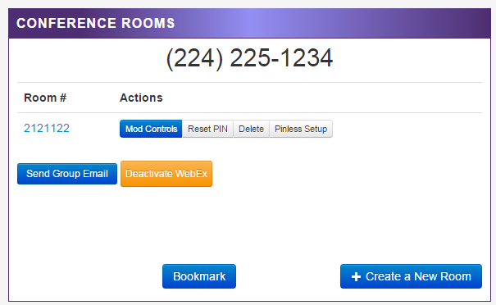

* 1. Enter a unique conference room number and a pin. For my real room I used my seven-digit cell number and for my pin I used the last four digits of my cell number. Be sure to check Pinless, then click **Create Conference Room**.
  2. Now click **Create WebEx** to associate a WebEx account with your conference room.
  3. Navigate to <https://icollaborate.webex.com> and then to the Meeting Center tab. It should look something like below.

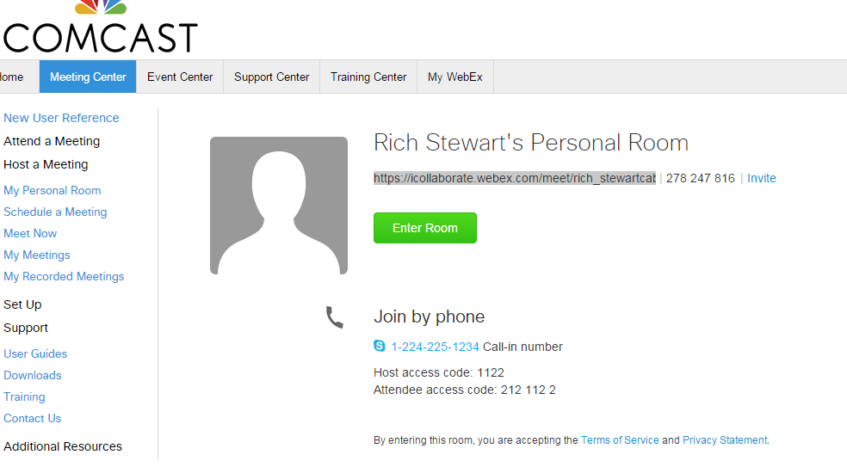

* 1. Bookmark the URL that was resolved as you’ll be able to use this moving forward for starting a WebEx session.
  2. Click **Enter Room**.
  3. You should now have a live WebEx session from which you can copy and share the WebEx URL, share your screen, pass control, etc.
  4. Note that the WebEx URL for a specific conference room (like the one you just created) is unique, so you can save it and include it in a meeting invitation without firing up a session.

1. Database Access
   1. Request appropriate database access from Mike Degrado.
      1. Give him your NT account.
2. VPN Access if Needed
   1. \\cchclu05\public\gr\VPN download software from this location
   2. Remote VPN Access Request
      1. Go to <http://westsupport/> and scroll to the bottom and select VPN access in the Networking column.

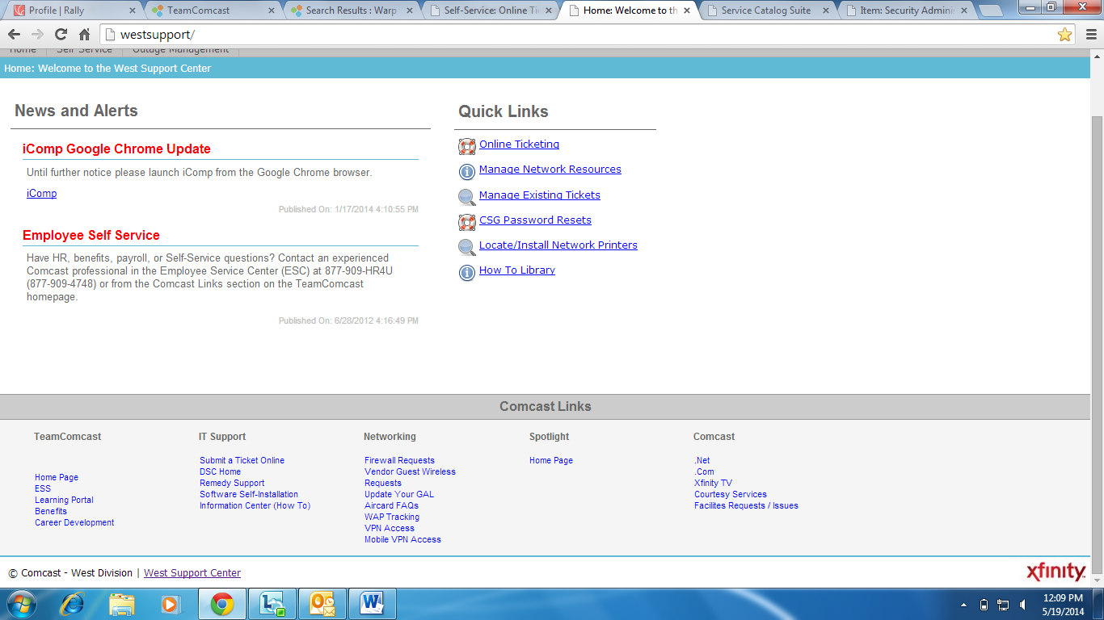

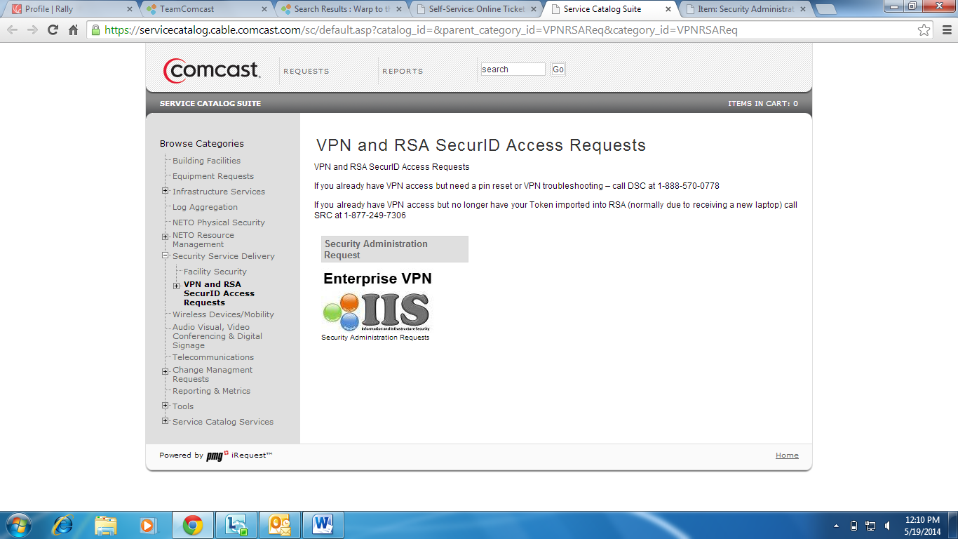

1. Click on Security Administration Request
2. Fill out the entire VPN Request Form. You might need to ask your manager or call 7-HELP to find out what Regional IT Manager to use (If it’s already filled out, leave it as is).
3. The form should look similar to the screen shot below. Request for yourself, select Corporate, search for your supervisor’s name and the information should self-populate, select Yes for Comcast Hardware if you are using a Comcast laptop, select No for RSA token, select Yes for Enterprise VPN, select No for Firepass and Engineer Access.
4. Ask a team member if you need help with business justification. Click submit when finished.

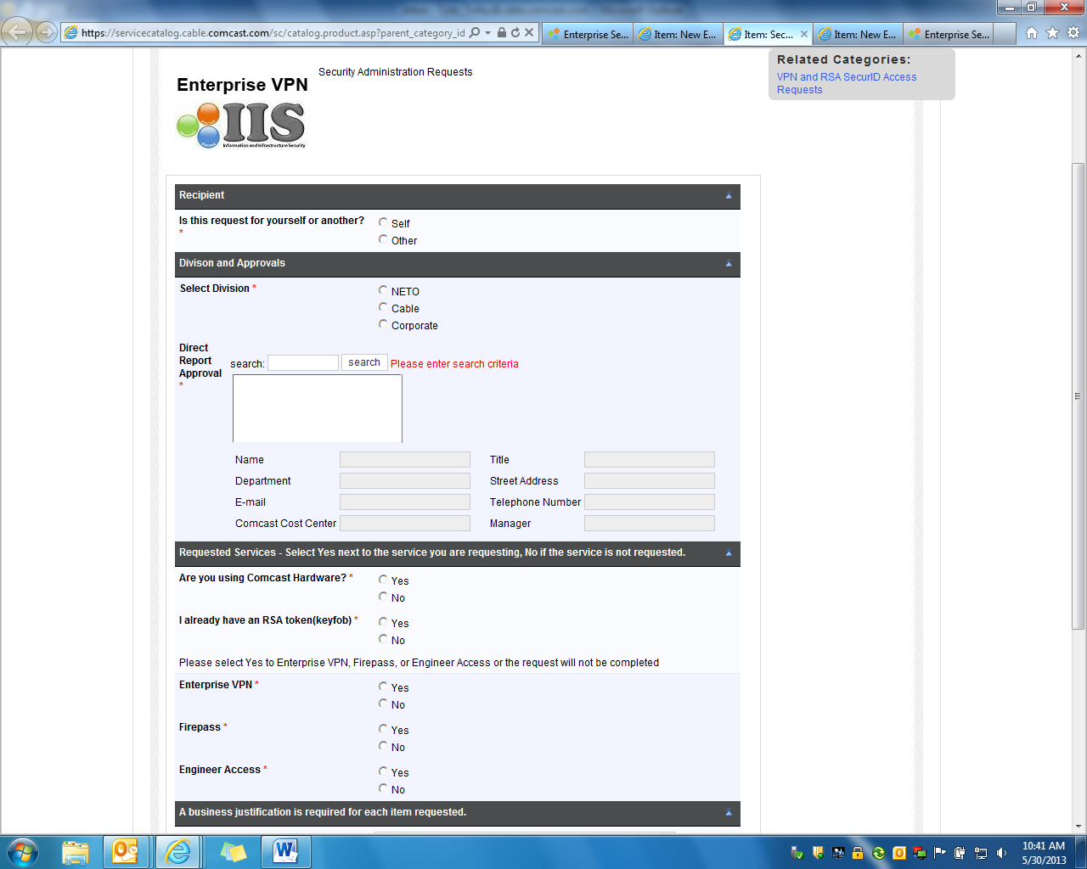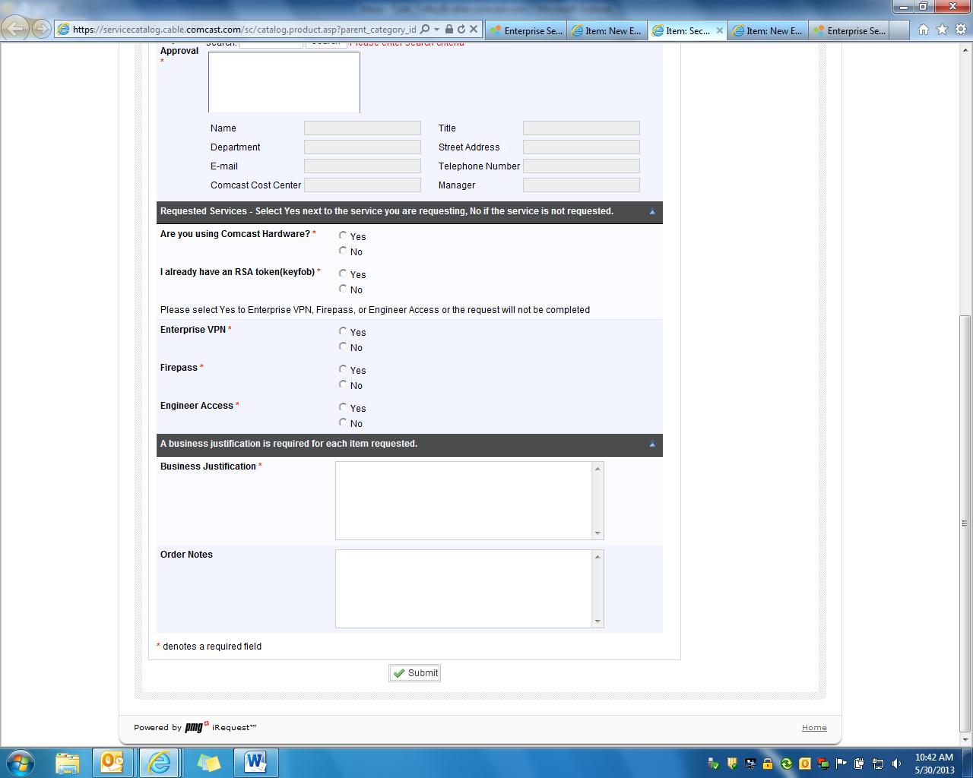

1. After submitting the request, you will receive an email in which you need to agree to the terms before being allowed VPN Access.
2. After your request has been approved you will receive an email saying “Welcome to CADA”
   * + - 1. Follow the instructions in the email
       1. Enter your network password
       2. Read the warning
       3. Click the agreement box
       4. Click the ‘Submit’ button
       5. You will then see a confirmation screen verifying that your registration was successful and informing you that your eGrid has been e-mailed to you.
3. VPN login instructions with eGrid email
   * + 1. Save the eGrid pdf somewhere safe as you will need it every time you log into the VPN client.
       2. When you are ready to log into the VPN client, use the instructions in this email.
4. Software Installs
   1. Go to \\cogct-wc-03p\softwareInstalls
      1. Install Subversion if you are an ETL person
5. Aginity
   1. Go to \\cogct-wc-03p\NetezzaDocs\Netezza\nzClientInstall
   2. Open the Word document titled “Aginity Netezza Tool Setup”
   3. Follow the listed instructions
6. SQL Server
   1. To install SQL go to \\cxerep-ch2-02p\SQL2012install
   2. Go into the folder Enterprise_Edition
   3. Click on Setup, this may take some time
   4. Choose “New SQL Server stand-alone installation or add features to an existing installation.”
   5. Click next until you get the options of what to install
   6. Install these options for the client.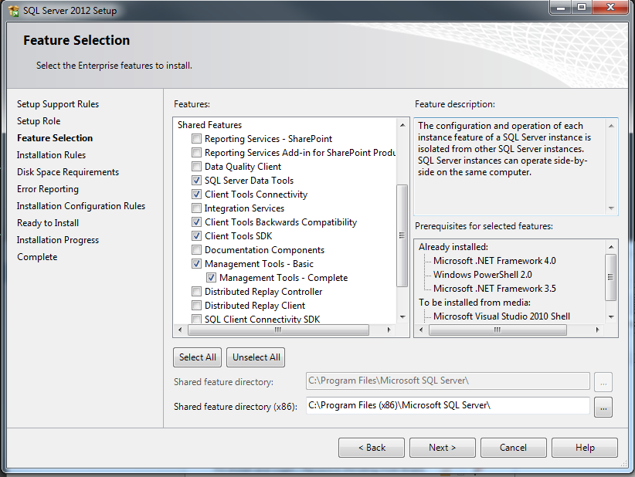
   7. Click Close
   8. Servers you might need access to:
      1. PACDCPIVRDB002 – Contact Mike Degrado to get access
      2. PACDCPIVRDB001 – Dev server
         1. NT Authentication
7. BMC Remedy and TTS
   1. To download Remedy go to <http://hqshopping/Shopping/>. This website works best on Internet Explorer.
   2. From the left side menu, scroll down and select “Remedy”
   3. Scroll over the box that says Remedy and a button should appear that says “request”
   4. Once you request the software it will be downloaded to your computer and then send you an email letting you know it has successfully been installed.
   5. TTS is the ticketing system. You will need to get a user login/password from Mike Degrado.
   6. Once Remedy is installed and you have a login, follow these steps and enter your username and password. NOTE: Password may start with a capitol, even if it states to use lowercase in the email.
      1. Go to Start Menu 🡪 All Programs 🡪 BMC Software🡪 AR System 1🡪 BMC Remedy User

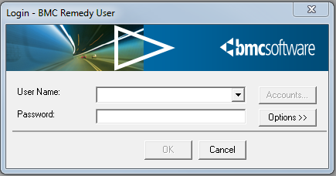

This will enable the Accounts button:

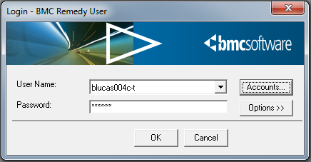

Click Accounts:

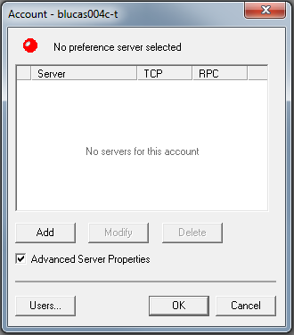

Click Add:

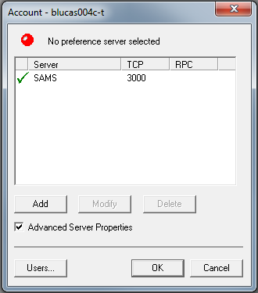

Type ‘SAMS’

Tab

Type 3000

Click OK.



1. Now click OK and it will log you in.
2. Einstein
   1. Talk to Brian Alleyne about getting access to Einstein.
3. Box.com access
   1. Go to <http://idm.cable.comcast.com/iam/im/comcast/ui7/index.jsp>?.
   2. In the upper left corner, click the plus sign next to users and it will expand a menu.
   3. From that menu select “Application Access Self Service”, and then click “Request for self”
   4. The form will have a drop down menu that says “Select Application”, choose box.com and click the arrow.
   5. Confirm your information and provide a business justification if necessary, then click submit.
   6. To sync your computer to Box.com you can go to <https://community.box.com/t5/Box-Sync/Get-Started-with-Box-Sync/ta-p/86>
4. Tableau Desktop Install if Needed
   1. Go to <http://www.tableau.com/esdalt> and download Tableau version 9.2.4.
   2. Start a trial until Sri Bolla can get you a license number.
   3. Go to \\cogct-wc-03p\Team Docs\Reporting\Tableau to learn more about the basics of the program.
   4. Send a request to Sri Bolla for tableau PROD and TEST access
5. Teradata access if needed
   1. How to’s

<https://wiki.io.comcast.net/display/NDW/NDW+Teradata>

http://commons.cable.comcast.com/groups/ndw-semantic

Install Teradata how to

<http://community.teamcomcast.com/workgroups/cet/extranet/CIOProjects/ndw/Shared%20Documents/90%20Operational/Teradata/Teradata_Developer_Reference/ODBC_Teradata_Steps_ToConnect_TD_DataBase_15.10.pdf>

* 1. Access request:

<http://community.teamcomcast.com/workgroups/cet/extranet/CIOProjects/ndw/Shared%20Documents/90%20Operational/Teradata/Teradata_Developer_Reference/CSMP_Teradata_NewUsers_AccessRequest_Process.doc>